Example Designed Question : Zecheng Zuo
“Design a motion-activated data-logger using a Cortex-M microcontroller that records 3-axis acceleration data to external SPI flash and periodically transmits summaries over UART at 9600 baud. The system must remain in ultra-low-power sleep until motion above a programmable threshold is detected, then capture 1 k samples at 200 Hz, store them with time-stamps, and return to sleep. Provide a complete hardware–software architecture, describe how you would implement the interrupt scheme (including priority settings), the flash-write protocol, and the UART summary packet format. Finally, explain your validation and power-profiling strategy.”

Why I Designed It This Way
- Analytical Skills – We must compare IMU options (analog vs digital, FIFO depth, sensitivity), size flash requirements, and analyse timing (sampling vs write latency, UART bandwidth).
- Creative Thinking – They must invent an energy-efficient trigger scheme (e.g., IMU built-in wake-on-motion, external analog comparator) and design a concise UART packet.
- Design Skills – Requires full system integration: sensor interface (I²C/SPI), DMA-driven sampling, interrupt priorities, non-blocking flash writes, power modes, and a test harness for current measurement and data integrity.

What It Aims to Test
- Ability to merge theory (interrupt latency, bus timing, power states) with practical design.
- Justified selection of MCU, sensor, flash size, and interface speeds.
- Development of a low-power, event-driven firmware architecture (ISR, DMA, circular buffers).
- Capability to communicate design decisions clearly with diagrams, timing charts, and a reproducible validation plan.

Additional Supporting Material
- Block & timing diagrams showing IMU-→DMA, DMA-→RAM-→SPI Flash, and periodic UART bursts.
- Notes on pitfalls – e.g., ensuring flash page-erase alignment; avoiding UART ISR blocking flash writes.
- Test strategy – using a shaker table or dropping the device, while logging current with a power analyser; loopback UART capture to verify packet integrity.

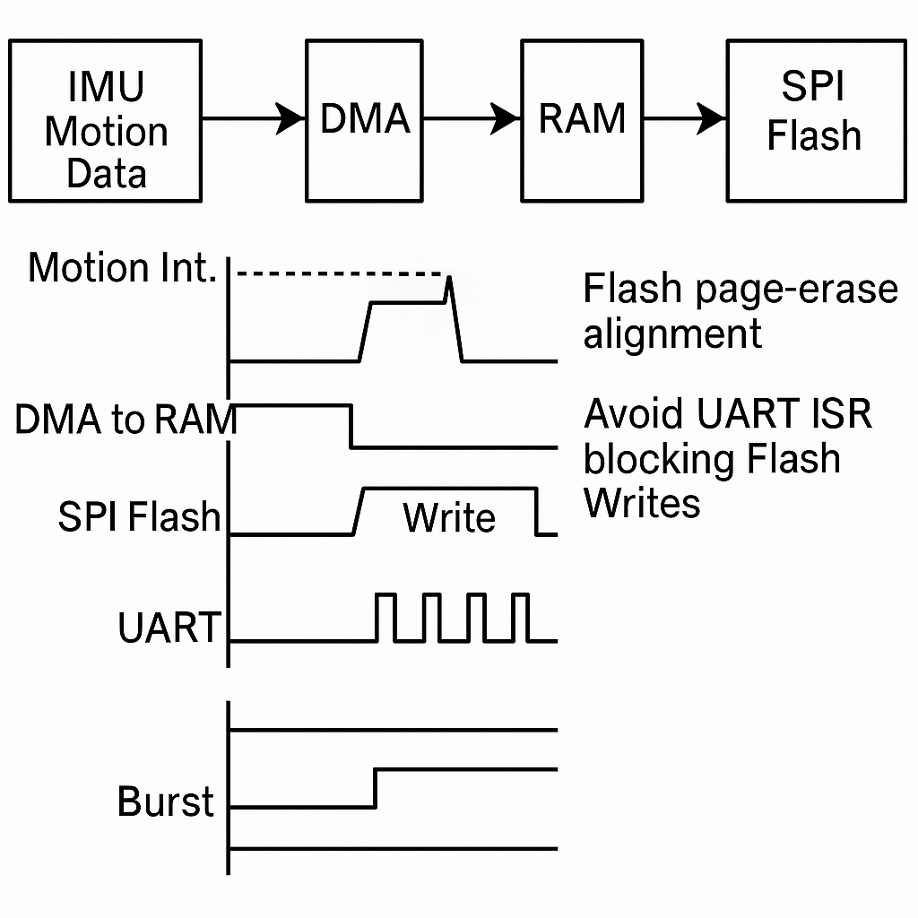

(Not Assessed : for reference only)
Answer – By Jiaxun Cai - ID: 221169346
(Cortex-M4 + LIS2DH12 IMU, Winbond ±3 V SPI-flash)
- Hardware: STM32L476 in stop-2 mode (200 nA). IMU INT1 pin wired to EXTI0; SPI flash CS on PB6.
- Firmware: INT1 wakes MCU; DMA streams 3×16-bit samples at 200 Hz into a 2 k buffer; when full, SPI DMA writes one 512-byte page (timestamp + data). UART timer every 60 s sends min/mean/max magnitude bytes.
- Power: 1.8 mA while sampling, <5 µA sleep.
- Testing: Use Keysight N6705C for current profile; compare UART summary with Excel FFT of raw log.

Answer – By Junyi Dong - ID: 221169195
Chooses nRF52832 (Cortex-M4) and MPU-6050 with FIFO
- FIFO counts 1 k samples internally; MCU wakes just once to burst-read FIFO via 400 kHz I²C, store to QSPI NOR.
- CRC16 appended per packet; UART summary includes RMS g-level and time since last event.
- Verification by dropping device from 10 cm and plotting captured acceleration in Python.

Answer – By Zijie Lan - ID: 221169232
Uses Cortex-M0+ (KL27Z) + ADXL372 (high-g)
- Motion threshold set via ADXL372 In-Run mode; MCU clocked at 48 MHz only during flash writes.
- Circular ping-pong RAM buffers; SPI flash “Auto-Page-Program” to cut erase + write time.
- UART frame = {Start, Samples, Peak, CRC}.
- Validation with vibration motor; logic analyser confirms SPI transaction timing.

Answer – By Yan Li - ID: 221169209
Emphasises ultra-low-power
- MSP432 in LPM3; LIS3DH wake-up; writes to FRAM instead of flash to avoid page-erase energy.
- After 10 events, UART spits CSV lines; host Python script logs to PC.
- Measures current with Joulescope; demonstrates 2-year life on CR2032.

Answer – By Mengtian Yuan - ID:221169162
Adds creative diagnostics
- STM32G0 + BMI160; dual-DMA: one DMA copies samples to RAM, second DMA streams directly to flash while CPU sleeps (link mode).
- UART summary includes checksum and configurable threshold via command packet from PC.
- Thermal camera ensures no hotspots; oscilloscope verifies INT latency (<8 µs).

A Declaration of GenAI Use
No GenAI tools were used in question design.

